Bulk SMS and Email Delivery System

# Aryan Dame1*, Drishti Lalwani2, Anirudha Khode3, Aditya Trivedi4, Anurag Chouhan5

**Department of Computer Science and Engineering,**

**Acropolis Institute of Technology and Research, Indore, M.P.**

**Abstract:** The dissemination of large numbers of email and SMS messages is referred to as bulk emailing and messaging. This is utilized by media companies, enterprises, banks for marketing and fraud control, and consumer brands for a range of purposes including entertainment, enterprise, and mobile marketing. The advantage of bulk emailing and messaging is its ability to send multiple emails and SMS messages to the intended recipients with reliability, which expands the capability of normal text messaging services.

In academic settings, the benefits of bulk emailing and messaging can be used to enhance classroom interactions and establish a virtual community as a public relations system. For example, teachers can conduct mobile quizzes with their students through email and SMS. Additionally, the system provides an information service, such as sending special announcements, news, and relevant information to students and other related recipients. This research aims to develop a system that incorporates mobile and web technology to improve and support students' learning and public relations through wireless communication.

Bulk emailing and messaging are commonly used for a variety of purposes, including alerts, reminders, marketing, notifications, and communication between staff and customers. It allows you to deliver emails and SMS messages to mobile devices globally.

**Introduction**: In this research work, we will examine the bulk email and messaging sender and its use in sending a large number of emails and messages in an organization for informational alerts. Text Local states that the majority of email and messaging senders are most effective in large commercial organizations for sending bulk emails and messages. Logon Utility offers a bulk email and SMS gateway that sends messages directly to mobile phones. In other words, we have a useful tool that sends bulk emails and SMS messages via the internet to people on handheld devices.

**Proposed Work:** Bulk email and SMS refer to sending quick and brief emails to many individuals, the number of which can range from hundreds to thousands. The same message is sent to all people on a list. This service is typically used for sales promotion and advertising of products and services. For example, an organization can inform people about an upcoming event, such as a concert or the launch of a new product. However, these messages are usually sent only to individuals who have voluntarily signed up to receive emails or SMS messages from the organization. Sending unsolicited emails and SMS messages can irritate potential customers and be perceived as harassment.

**Existing Systems:**

* **Plivo**

1. **Overview:** Plivo's cloud communication platform provides an easy, fast, and scalable solution for companies to modernize their business communication. Its API platform allows businesses to quickly integrate voice and text messaging capabilities, including SMS and MMS, into their applications, and it offers SIP trunking and phone number rental services.
2. **Benefits:**

* Easy Integration
* Fast API Call Speed
* Multiple Communication Options
* Available Documentation

1. **Drawbacks:** The platform is slightly expensive and primarily intended for business use.
2. **Reference:** [https://www.plivo.com](https://www.plivo.com/)

* **Atomic SMS Sender**

**Top of Form**

1. **Overview:** This web-based application enables users to send bulk SMS messages from their phones or computers. The application supports over 700 mobile operators and can be used to send SMS to over 200 countries.
2. **Benefits:**

* Easy Contact Management
* Ability to Schedule Messages Anytime
* Available Live Online Training and Documentation
* Offers Unsubscribe Feature for Enhanced User Experience

1. **Drawbacks:**

* No 2-way messaging
* No support for MMS or mobile coupons
* SMS delivery time may not always be reliable

1. **Reference:** <https://sourceforge.net/software/product/Atomic-SMS-Sender/>

* **My SMS Mantra**
  1. **Overview:** My SMS Mantra is free software that enables users to send bulk SMS online through an Excel plug-in. To use it, simply download and install the plug-in, and stay connected to your clients and customers through SMS.
  2. **Benefits:**
  + Interfaces smoothly with other applications through its API
  + Easy to set up and comes with no hidden costs.
  + Offers free technical support
  + Supports 2-way messaging through its Mantra Communicator
  1. **Drawbacks:**
* Has a short word limit for SMS messages
* May lose data if faced with network issues
  1. **Reference:** <https://www.mysmsmantra.com>

**Methodology:** Designing a bulk email and SMS-sending web application requires several steps:

1. **Determine the purpose and goals of the application:** The first step is to clearly understand the purpose and goals of the application. This includes identifying the target audience, the types of messages to be sent, and the features and functionalities required to meet the needs of the users.
2. **Conduct market research:** Conduct market research to understand the existing solutions and their features. This research will help us understand the competition and the best practices in the industry.
3. **Define the technical requirements**: Based on the purpose and goals of the application, define the technical requirements, including the hardware and software needed, data storage requirements, and security measures. In this application the hardware needed is just a PC with a normal hardware configuration.

**The basic needs are as follows**:

**Hardware Requirements**:

* Processor: Intel core i3
* RAM: 2GBs
* Hard Disk: 80 GBs (Memory Consumption: 5 MB while in use)

**Software Requirements:**

* Operating System: Windows 7
* Front – End: Python Tkinter
* Back – End: MySQL

1. **Design the user interface:** The next step is to design the user interface. The user interface should be user-friendly and intuitive, allowing users to easily send bulk emails and SMSs. In this project, we will use Tkinter, a GUI library in Python, to develop the front end of our application.
2. **Develop the back-end:** The back-end of the application should be developed to handle the data storage, user management, and the sending of emails and SMSs. The back end should be scalable, secure, and reliable. We are using relational database management system in our project. Language used for querying is MySQL.
3. **Integrate with third-party services:** If necessary, integrate the application with third-party services such as email and SMS gateways, payment gateways, and marketing automation tools. For this project, we have chosen Twilio as a third-party tool.
4. **Test and deploy**: Once the development is complete, test the application thoroughly to ensure that it works as expected. After testing, deploy the application on a web server and make it available to the users.

By following these steps, we will design a bulk email and SMS-sending web application that meets the needs of your target audience and provides a seamless experience to users.

**Flowcharts:**

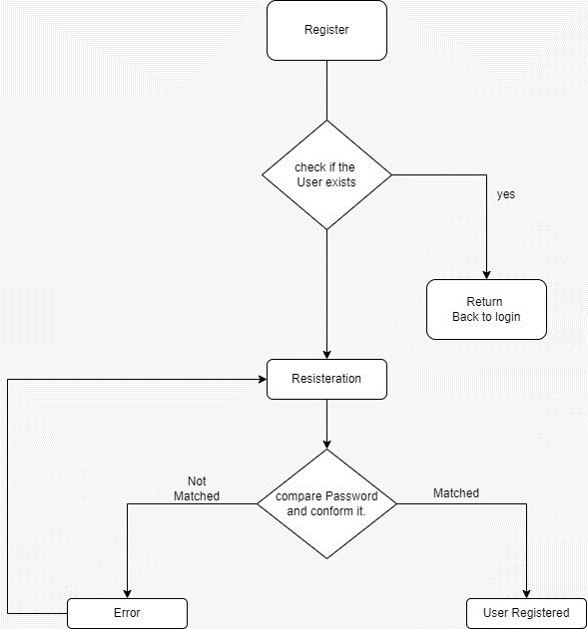

Figure 1: Registration Flowchart

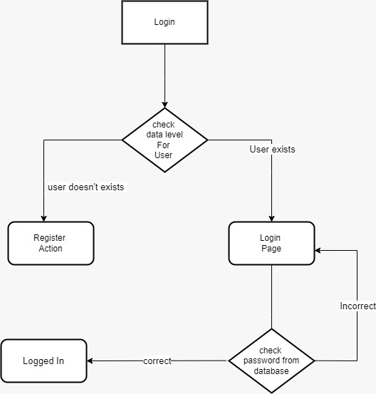

Figure 2: Login Flowchart

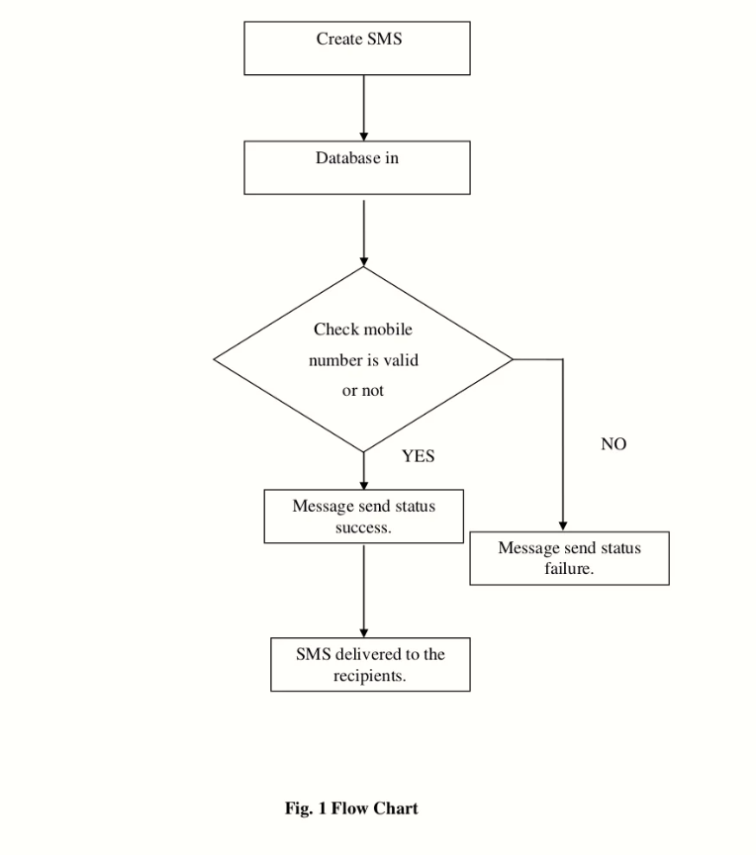

Figure 3: Message Flowchart

**Conclusion:** This project is highly beneficial in various organizations, colleges, banking, companies, E-Commerce, Market News, government and public utilities, logistics, media and entertainment, travel and tourism industry, etc. It enables organizations to notify their customers or users about new updates, such as shipping updates in logistics, invoices, bills, and tracking details via email or SMS. In the media and entertainment industry, it can invite the audience to an FM/TV show or encourage them to vote for their favorite contestants in a reality show. It also plays a vital role in the travel and tourism industry by sending itineraries and travel routes via email or SMS, making the journey more convenient for the customer.

**References:**

[**https://www.researchgate.net/publication/228680297_Applying_of_bulk_SMS_system_to_enhance_educational_communications**](https://www.researchgate.net/publication/228680297_Applying_of_bulk_SMS_system_to_enhance_educational_communications)

[**https://www.researchgate.net/publication/362344203_BULK_SMS_SERVICE_WITH_CUSTOMIZATION**](https://www.researchgate.net/publication/362344203_BULK_SMS_SERVICE_WITH_CUSTOMIZATION)

[**https://ijsrem.com/download/implementation-of-bulk-email-and-sms-system-to-enhance-way-of-communication/**](https://ijsrem.com/download/implementation-of-bulk-email-and-sms-system-to-enhance-way-of-communication/)

[**https://www.slideshare.net/nkniteen/bulk-sms-sender-project-report**](https://www.slideshare.net/nkniteen/bulk-sms-sender-project-report)

[**https://www.ijcseonline.org/pub_paper/24-IJCSE-00652.pdf**](https://www.ijcseonline.org/pub_paper/24-IJCSE-00652.pdf)

[**https://arxiv.org/pdf/2006.16508.pdf**](https://arxiv.org/pdf/2006.16508.pdf)

[**https://www.emailyard.com/**](https://www.emailyard.com/)

[**https://mailchimp.com/**](https://mailchimp.com/)

[**https://ir.kiu.ac.ug/bitstream/20.500.12306/6016/1/img05599.pdf**](https://ir.kiu.ac.ug/bitstream/20.500.12306/6016/1/img05599.pdf)

[**https://www.academia.edu/11827748/Bulk_Messaging_System**](https://www.academia.edu/11827748/Bulk_Messaging_System)

[**https://github.com/topics/bulk-email-sender**](https://github.com/topics/bulk-email-sender)

[**https://github.com/ghpranav/python-bulk-mail**](https://github.com/ghpranav/python-bulk-mail)

**Bottom of Form**